1.0 | Introduction
1.1 | Coronavirus disease 2019 (COVID-19) is an infectious disease caused by severe acute respiratory syndrome coronavirus 2 (SARS-CoV-2). Common symptoms include fever, cough and loss of smell and taste. While most instances result in mild symptoms, some progress to acute respiratory distress syndrome (ARDS), multi-organ failure, septic shock, blood clots and death. The disease is most contagious during the first three days after the onset of symptoms, although spread is possible before symptoms appear, or in the absence of symptoms and from people who do not show symptoms at any time.
1.2 | The virus is primarily spread between people during close contact, where the risk of infection increases the closer you are, and the amount of time you spend in proximity to infected person(s). Most often transfer of the virus is via small droplets produced by coughing, sneezing, and talking, however less commonly, people may become infected by touching a contaminated surface and then touching their face. Studies indicate that the virus can survive for up to 72 hours outside of the body.
1.3 | Currently, there are no vaccines or specific anti-viral treatments for COVID-19. The recommended measures to prevent infection include maintaining physical distance from others (especially from those with symptoms) and quarantine (especially for those with symptoms) together with frequent hand washing and keeping unwashed hands away from the face.
1.4 | To curb the spread of the coronavirus, the Welsh & UK Government implemented a series of measures including advising people to work from home if possible. As these measures are lifted, the purpose of this procedure is to ensure that any return to work / study is undertaken in accordance with legislation and guidance.
1.5 | This procedure adopts a risk-based approach to minimise the risk of COVID-19, with the emphasis on minimising contact between individuals and promoting hygienic practices. Where different, this procedure follows Welsh Government legislation in the first instance, followed by that provided by the Health and Safety Executive and UK government.
2.0 | Scope
2.1 | This procedure applies to staff and students of the University of South Wales when considering the measures necessary to authorise the safe use of premises for required work that cannot be undertaken at home
3.0 | References
3.1 | Health Protection (Coronavirus Restrictions) (Wales) Regulations 2020 & related guidance
3.2 | UK Government Corona virus advice and guidance
3.3 | NHS Wales guidance (June 2020)
3.4 | World Health Organisation guidance (June 2020)
3.5 | Health and Safety Executive Coronavirus latest advice and guidance
3.6 | Health & Safety at Work Act 1974
3.7 | Management of Health & Safety at Work Regulations 1999
4.0 | Definitions
 | For the purpose of this procedure, the following definitions apply:
Required Work | Work, including student coursework, that, due to the nature of the tasks, materials or equipment involved, cannot be carried out at home and has been approved by Executive subject to completion of a risk assessment.
All Reasonable Measures | As defined by the Welsh Government, (advice 12th June 2020), taking all reasonable measures is an objective test that is intended to be applied consistently. The principle control measure is social distancing. Where it is not physically possible to achieve social distancing, then other measures outlined in the procedure must be applied. For further information click here
Social (Physical) Distancing | Maintaining a distance (currently 2 metres) between individuals to help reduce the likelihood of inhaling water droplets potentially containing COVID-19 exhaled by persons during social interaction. For further information click here
Extremely Vulnerable  People | Persons classed as being at a higher risk of developing serious illness if exposed to COVID-19 because of a serious underlying health condition. For further information click here
Vulnerable  People | Persons who, due to an existing health condition, age or other specified reason, is considered more likely to contract the Covid-19 virus and/or suffer more serious consequences. For further information click here
Good Respiratory Hygiene Practices | Covering the mouth and nose with a tissue when coughing or sneezing or coughing or sneezing into the upper sleeve if no tissue is available.  Using in the nearest waste receptacle to dispose of the tissue after use.  Washing hands with soap and water, alcohol-based hand rub, or antiseptic handwash after having contact with respiratory secretions and contaminated objects/materials.

5.0 | Process Flowchart
6.0 | Procedure
6.1 | General Principles
Note: | Images and illustrations providing examples of the control measures outlined in this procedure are shown in Appendix 1.
6.1.1 | In accordance with current Government guidance, University staff and students must continue to work from home where it is possible to do so.
6.1.2 | Persons involved with ‘required work’ will be allowed to return where risk assessments, taking account of the location, tasks and activities and individuals, show that appropriate control measures can be implemented. Before any work commences, approval must be given by the appropriate member of the University Executive. Any significant changes will also require approval.
6.1.3 | Risk control measures must be applied in the order listed below, all reasonable measures must be taken before moving to the next control measure and the risk must be reduced to the lowest reasonably practicable level. A question to ask is “Are you able to justify the control measure selected over one that offers more protection”?
6.1.4 | Evidence suggests that maintaining a social (physical) distance of 2 metres is the most effective measure for reducing the number of infections. This may be achieved by:
 | - using several rooms
 | - physically arranging spaces and work areas such as labs, teaching rooms to keep people 2 metres apart
 | - implementing one-way systems in rooms, buildings and outdoor areas and / or one in and out system
 | - marking areas using floor paint or tape demarcating 2m distances
 | - providing signage to remind people to keep a 2m distance
 | - staggering arrival, break, collection, waiting and departure times to reduce the number of people on site and pressure on public transport
 | - limiting access to buildings and areas e.g. regulate the use of locker rooms, changing areas and other facility areas to reduce concurrent usage
 | - restricting/reducing movement of people inside and between buildings
 | - keeping the number of people on site to a minimum, this includes colleagues, students, contractors and visitors. Only absolutely essential people should be allowed, taking account of the number of people needed to carry out and supervise the work safely
 | - modify the task to allow social distancing of 2 metres to be achieved e.g. job rotation, using lifting aids to avoid team lifting and handling
6.1.5 | Where social distancing cannot be achieved, the following measures may be used singularly or in combination, as deemed appropriate:
 | - use screens or barriers to separate people from each other
 | - use back to back or side to side working rather than face to face
 | - keep the task and activity time as short as possible
 | - reduce the number of people carrying out the task and/or number of people in the area
 | - reduce the number of people each person has contact with by using fixed teams or partnering so each person works with only a few others and on the same shift. Where contact is unavoidable, it happens between the same people this includes on breaks.
 | - use face masks and other personal protective equipment (PPE)
 | - increasing the frequency of surface cleaning, hand washing and practising respiratory hygiene – ‘catch it, bin it, kill it’
 | - where people must work face to face for sustained periods with more than a small group of fixed partners, then determine whether this activity can safety go ahead
 | - ensuring a supply of fresh air (e.g. keeping windows open)
6.1.6 | Where possible, tools, equipment, appliances and workstations should be assigned to an individual and not shared, or where this is not practicable, shared by the smallest possible number of people and cleaned regularly. Hot desking practices should be avoided and self- cleaning materials made available where possible.
6.1.7 | Where people directly pass things to each other including tools, equipment etc or deliveries adopt ways to remove or minimise direct contact, such as using picking-up and dropping-off collection points, remote ordering. Store items that have been returned, donated, brought in for repair or extensively handled, for example in a container or separate room for 72 hours before re-use, or clean such items with cleaning products.
6.1.8 | Encouraging storage of personal items and clothing in personal storage spaces, for example lockers, during working hours. Where applicable consider asking colleagues to change into work clothing and equipment on-site using appropriate facilities/changing areas, where social distancing and hygiene guidelines can be met. Remove personal belongings from vehicles especially where vehicles are shared / multiple occupancies. Encouraging washing of work clothes at the end of each day where possible.
6.1.9 | Additional PPE to that normally used is not usually required in relation to COVID-19, however where social distancing cannot be achieved or maintained, risk assessments must be reviewed to determine if additional PPE is necessary. In reviewing assessments, account must be taken of the method of transfer of COVID-19, if social distancing can be maintained and the enclosed nature of spaces. Advice on the different types of PPE is available from the HSE and PPE suppliers. Where PPE is required, advice, guidance and training must be provided on fitting and wearing the PPE correctly.
6.1.10 | Currently the wearing of face covering is not compulsory at USW. Face coverings are not regarded as personal protective equipment. Evidence suggests that wearing a face covering provides limited protection and does not replace the need for social distancing, handwashing and practising respiratory hygiene.
6.1.11 | In all instances, cleaning, handwashing and practising respiratory hygiene is of paramount importance. Everyone should promote regular cleaning of hands and respiratory hygiene – ‘catch it, bin it, kill it’. Advice on handwashing is available here. Encourage hand washing before entering or leaving buildings and rooms or before boarding vehicles. Increasing cleaning frequency for buildings, space, vehicles, tools and equipment etc.
6.1.12 | All persons using University locations and premises must be informed of the risk assessment findings and of the control measures in place. This can be achieved by:
 | - e-mail briefings/induction in advance of persons returning to work
 | - specific instructions for the use of certain areas, carrying out certain tasks and activities
 | - messages via social media
 | - ‘virtual’ meetings via ‘Teams’ etc.
 | - Website information
 | - signage
6.2 | Location
6.2.1 | A risk assessment must be completed before a location can re-open by someone with appropriate skills, knowledge and training. The purpose of the risk assessment is to identify the hazards and control measures required to manage general health and safety and COVID-19 in the building.
6.2.2 | The risk assessment element that considers the location and premises must be undertaken through collaboration between the Estates & Facilities Department, Faculties and Professional Services as appropriate.
6.2.3 | In considering control measures for locations and premises, the following should be taken into account:
 | - the maximum number of people that can be accommodated in teaching rooms, laboratories, offices etc. in order to maintain social distancing
 | - managing common areas where people may congregate or use, for example, entry and exit routes, corridors, lifts, stairways, walkways, toilets etc.
 | - the use of pedestrian one-way systems
 | - the use of timed intervals
 | - the provision of hand washing / hand sanitising facilities, particularly at entrances and exits
 | - the provision of covered waste bins for discarding tissues, wipes, used face coverings/masks etc.
 | - the use of signage to advise and remind persons of key information
 | - cleaning routines that take account of:
 | - the number of persons using the location/premises
 | - the nature of the tasks and activities carried out
 | - objects and surfaces that are touched regularly e.g. handles, touchpads, handrails etc.
 | - shared equipment
 | - timings between activities etc.
6.2.4 | In addition to 6.2.3 above, risk assessments must also take account of emergency situations such as an activation of the fire alarm, spillages of hazardous substances, first aid requirements etc.
6.2.5 | All servicing, maintenance and statutory inspection must be up to date before the location is re-opened. Ventilation and air conditioning systems should be reviewed to determine modes of operation. Determine whether additional ventilation is required.
6.3 | Work Tasks and Activities
6.3.1 | Existing risk assessments must be reviewed, the control measures for managing COVID-19 when undertaking that task or activity must be detailed in the risk assessments. It is possible, where the task or activity is similar or takes place in a similar environment to prepare one risk assessment to cover those similar tasks or activities.
6.3.2 | Task and activity risk assessments will be undertaken by the relevant Faculty/Professional Service and recorded on the Assessnet system with uploaded supporting documentation where available.
6.3.3 | Faculties/Professional Services must support Estate & Facilities in determining layouts, flows and the numbers allowed in teaching rooms and specialist areas such as labs and clinical areas for example.
6.3.4 | All Faculties/Professional Services responsible for servicing, maintenance and statutory inspections must ensure they are up to date before any task or activity commences.
6.4 | The Individual
6.4.1 | It is recognised that COVID-19 affects certain groups of people more than others as outlined below.
6.4.2 | Extremely Vulnerable People
 | People in this group have been requested to ‘shield’ by staying at home in order to reduce social contact as far as possible.
6.4.3 | Vulnerable People
 | People in this group have been asked to follow social distancing particularly stringently and practice handwashing and good respiratory hygiene practices.
6.4.4 | Black, Asian and Minority Ethnic (BAME)
 | Recent studies indicate that that coronavirus is having a disproportionate impact on people from BAME backgrounds in the workplace. A risk assessment approach has been adopted to review the impact on members from the BAME community.
6.4.5 | To help assess whether a person can return to work, an Individual Risk Assessment form as shown in Appendix 2 must be completed for all returning staff. The Individual Risk Assessment takes account of the factors recognised as making individuals more vulnerable from COVID-19 and must be used as part of the overall risk assessment to help identify the control measures required and to assist with the authorisation to work decision making process.
6.5 | Responsibilities
6.5.1 | Appropriate members of the University Executive will be responsible for authorising required work, where its accepted that there’s suitable justification for the work to go ahead and a risk assessment is in place. No work must commence until such authorisation is given.
6.5.2 | Deans of Faculty, Directors of Professional Services are responsible for ensuring a process of risk assessment is in place, within their area of responsibility, for the purpose of identifying the appropriate control measures necessary to minimise the likelihood of infection from COVID-19.
6.5.3 | Within their area of control, Faculty and Professional Services Managers are responsible for:
 | - ensuring risk assessments are carried out or reviewed to take account of the hazards posed by COVID-19
 | - ensuring all necessary persons are informed of the measures in place for controlling the hazards associated with the work being carried out and posed by COVID-19
 | - periodically monitoring the control measures to check they are being followed, with more frequent checks made initially (at least weekly) to help ensure suitability. Such monitoring could include visiting the location as part of a necessary site visit, obtaining feedback from those implementing the control measures or remotely via video link
6.5.4 | Staff and students are responsible for:
 | - following all the measures in place to control the hazards associated with COVID-19 and other hazards associated with any work being undertaken
 | - immediately informing their line manager/course leader if they develop any symptoms associated with COVID-19 and for self-isolating until receiving confirmation from an appropriate medical professional that it is safe to return to a social setting
 | - immediately informing the University if any person in their household develops symptoms associated with COVID-19 and for self-isolating until receiving confirmation from an appropriate medical professional that it is safe to return to a social setting
 | - informing the University of any circumstances where they believe they are classed as vulnerable or extremely vulnerable
 | - informing the University if a member of their household is regarded as vulnerable or extremely vulnerable
 | - informing the University immediately if they become aware of any circumstances that suggests any control measures in place are ineffective
6.6 | Work Placements
6.6.1 | Students required to complete work placements must, under current guidance, work from home where possible. Confirmation must be obtained by the placement organiser from placement providers engaged by the University that this can be achieved.
6.6.2 | Where it is not possible for the student to complete the necessary work from home, and attending the workplace cannot otherwise be avoided, confirmation must be received from the placement provider that the control measures applicable to the country in which the placement is taking place will be implemented.
6.6.3 | Students organising their own work placements must be informed of the above.
6.7 | Documentation
Document Reference | Title | Minimum Retention Period

Appendix 1 Examples of social distancing measures

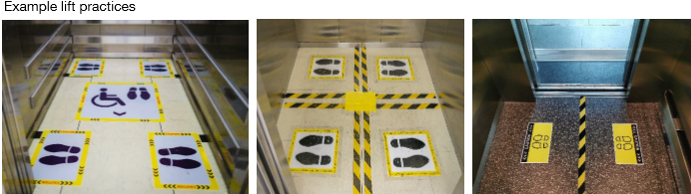

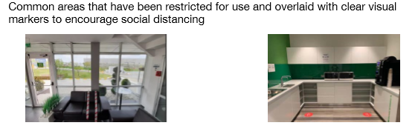
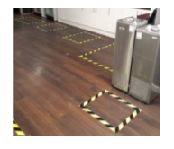

Example workstations / areas
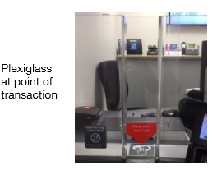
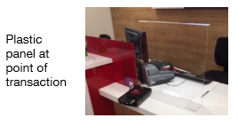
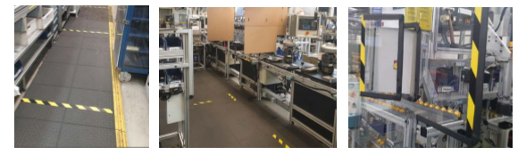

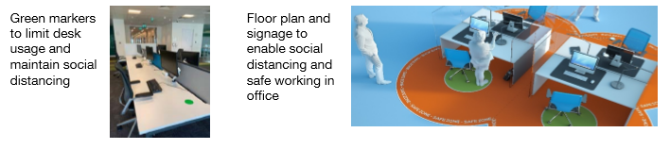

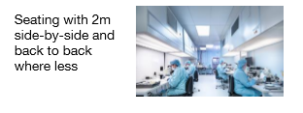
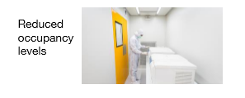

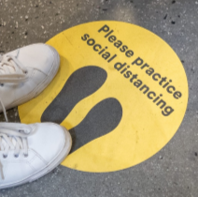
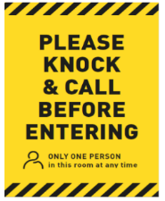
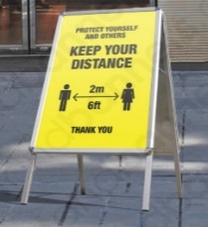
Examples of signage
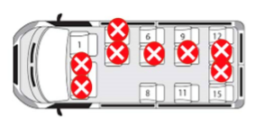

Appendix 2
COVID-19 INDIVIDUAL RISK ASSESSMENT

Current Government legislation and guidance recognises that COVID-19 affects certain groups of people more than others, with those exposed to the virus more at risk of developing serious illness. The groups affected are:

- Extremely Vulnerable People
- Vulnerable People
- Black, Asian & Ethnic Minority People

The purpose of this individual risk assessment is to identify USW colleagues or students who fall within one or more of these groups and ensure appropriate measures are in place to manage the risk before returning to undertake ‘required work’.

Extremely Vulnerable People

Extremely vulnerable people refer to people who have one or more of the pre-existing and long-term serious health conditions listed below:

Extremely Vulnerable People
- solid organ transplant recipients
- people with specific cancers:
- people with cancer who are undergoing active chemotherapy or radical radiotherapy for lung cancer
- people with cancers of the blood or bone marrow such as leukaemia, lymphoma or myeloma who are at any stage of treatment
- people having immunotherapy or other continuing antibody treatments for cancer
- people having other targeted cancer treatments which can affect the immune system, such as protein kinase inhibitors or PARP inhibitors
- people who have had bone marrow or stem cell transplants in the last 6 months, or who are still taking immunosuppression drugs
- people with severe respiratory conditions including all cystic fibrosis, severe asthma and severe Chronic Obstructive Pulmonary Disease (COPD)
- people with severe single organ disease (e.g. Liver, Cardio, Renal, Neurological)
- people with rare diseases and inborn errors of metabolism that significantly increase the risk of infections (such as Severe Combined Immunodeficiency (SCID), homozygous sickle cell)
- people on immunosuppression therapies sufficient to significantly increase risk of infection
- pregnant women with significant heart disease, congenital or acquired
- children up to the age of 18 with significant heart disease, congenital or acquired
In addition, for people living in England, those classed as clinically extremely vulnerable, based on clinical judgement and an assessment of their needs.

Extremely vulnerable people have received a letter from the Chief Medical Officer for Wales or NHS England. Under current Welsh Government legislation and guidance, any person within this group must not go to their place of work if this is outside their home, work should be undertaken from home. For people living in England, this group is referred to as clinically extremely vulnerable individuals and are strongly advised not to work outside the home.

At USW, those categorised as being extremely vulnerable must continue to work from home until Welsh Government guidelines indicate otherwise. If you are classified as extremely vulnerable, there is no need to complete the risk assessment. Please inform your line manager / course leader that you are categorised as extremely vulnerable, there is no need to disclose your medical condition.

Vulnerable People

Vulnerable people refer to people who fall within one or more of the categories below.

Vulnerable People
- aged 70 or older (regardless of medical conditions)
- under 70 with an underlying health condition listed below (i.e. anyone instructed to get a flu jab as an adult each year on medical grounds):
- chronic (long-term) respiratory diseases, such as asthma, chronic obstructive pulmonary disease (COPD), emphysema or bronchitis
- chronic heart disease, such as heart failure
- chronic kidney disease
- chronic liver disease, such as hepatitis
- chronic neurological conditions, such as Parkinson’s disease, motor neurone disease, multiple sclerosis (MS), a learning disability or cerebral palsy
diabetes
- problems with your spleen – for example, sickle cell anaemia or if you have had your spleen removed
- a weakened immune system as the result of conditions such as HIV and AIDS, or medicines such as steroid tablets or chemotherapy
- being seriously overweight (a body mass index (BMI) of 40 or above)
- those who are pregnant

Under current legislation and guidance, those who fall within the vulnerable people category must ensure social distancing measures are followed particularly stringently and practice hand washing and respiratory hygiene. Following the social distancing measures particularly stringently may mean agreeing to change their usual workplace, or role, or modifying the work environment so that they can work safely.
At USW, vulnerable people will be able to return to carry out required work provided measures are in place to maintain social distancing at all times. Where it is not possible to ensure social distancing stringently then where possible the role, tasks and activities should be modified to ensure social distancing.

If you qualify as vulnerable, there is no need complete the risk assessment. Please inform your line manager / course leader that you qualify as vulnerable. If you are pregnant, please refer to our New & Expectant Mothers’ Procedure.

Black, Asian & Ethnic Minority people

There is growing evidence that coronavirus is having a disproportionate impact on people from BAME backgrounds in the workplace. The Welsh Government has launched a two-stage online COVID-19 Workforce Risk Assessment Tool for those working in the NHS and social care which takes account of protected characteristics which may make a person more a risk from Covid-19.

NHS Wales Risk Assessment

USW has adopted this risk assessment as an exemplar of good practice to assess the risk to colleagues and students returning to undertake required work. It was developed for people working in Health and social care settings but can be related to Higher Education. Extremely vulnerable and vulnerable people need not complete the risk assessment. A link to the risk assessment is here. Please note USW has no access to the information you provide in this risk assessment.

Having complete the on-line risk assessment, please consider the following risk factors and assign the score shown as they apply to you.

Please use the risk evaluation matrix below to determine the control measures required for returning to work. Please inform your line manager / course leader of your score only, there is no need to disclose the reasons for the score.

You will not be permitted to return to on-campus activity until you have informed USW that you are categorised as Extremely Vulnerable/Vulnerable or have provided the risk score arising from the on-line risk assessment.

Risk Evaluation

0 – 3 | Low risk | May return to work for required work and social distancing can be achieved where possible, or if not, other control measures e.g. as outlined in 6.1.5 above.
4 – 6 | Increased Risk | Work from home where possible. May return to work where authorised and social distancing can be achieved as outlined in 6.1.4 above.
> 7 | Very High Risk | Work from home where possible. May return to work for specifically agreed tasks where social distancing can be strictly adhered to.

